knowledge based agent in Recommendation System

A knowledge-based agent (KBA) in a recommendation system is a software component that utilizes its understanding of the world to suggest items to users. Unlike collaborative filtering systems that rely solely on user ratings, KBAs employ a knowledge base to make recommendations.

Here's a breakdown of how it works:

* **Knowledge Base:** This is the core of the KBA, containing information relevant to the recommendation task. It can include details about products, users, and the relationships between them. Facts, rules, and expert knowledge are all stored here.
* **Inference Engine:** This component acts like a brain, applying reasoning techniques to the knowledge base. It analyzes information and user preferences to identify items that best match their needs.

**Here's why KBAs are valuable in recommendation systems:**

* **New User Compatibility:** KBAs can recommend items to new users who don't have a purchase history. The system relies on the knowledge base to understand user preferences based on their profile or initial interactions.
* **Explainability:** KBAs can often explain their recommendations. By understanding the reasoning behind the suggestions, users can trust the system more and make informed decisions.
* **Niche Applications:** For less common items, where user ratings might be scarce, KBAs can be particularly useful. They can leverage their knowledge of product features and user needs to provide relevant recommendations.

Overall, knowledge-based agents offer a powerful approach to recommendation systems, especially when combined with other techniques like collaborative filtering.

case-based recommender systems (CBRS) utilize user interaction and similarity metrics to refine recommendations! Here's a breakdown of the key points you mentioned:

**Cases as Targets:**

* In CBRS, users don't just specify constraints, they can also provide specific examples (cases) as starting points. These cases act as anchors or targets, guiding the system towards similar items.
* For instance, a user might show a picture of a dress they like and ask for similar styles.

**Similarity Metrics:**

* To find items similar to the target case, CBRS define similarity metrics. These metrics are essentially formulas or rules that determine how similar two items are based on their attributes.
* Remember the domain-specific rules we discussed earlier? Similarity metrics often play that role, tailored to the specific domain (e.g., fashion, movies) to accurately compare items.

**Interactive Refinement:**

* CBRS excel at iterative refinement. The initial recommendations are not the end point. Users can interact with the results in various ways to further personalize their search:
  + **Target Refinement:** If a user finds an item almost perfect, they can use it as a new target, adjusting specific attributes to their liking.
  + **Directional Critique:** Users can provide feedback by indicating unwanted features (e.g., dresses that are too long) or desired features (dresses in a different color). This helps the system narrow down the search based on user preferences.

**Benefits of Interactive Refinement:**

* **Gradual Personalization:** This user interaction allows for a more gradual and personalized recommendation process. Users can progressively guide the system towards their ideal item.
* **Flexibility:** It caters to users who might not be able to perfectly articulate their needs upfront. By interacting with the recommendations, they can explore options and refine their search.

**Overall, you've described a key strength of CBRS – their ability to adapt and learn from user interaction. This interactivity, combined with well-defined similarity metrics, allows CBRS to deliver highly personalized recommendations that become more accurate with each iteration.**

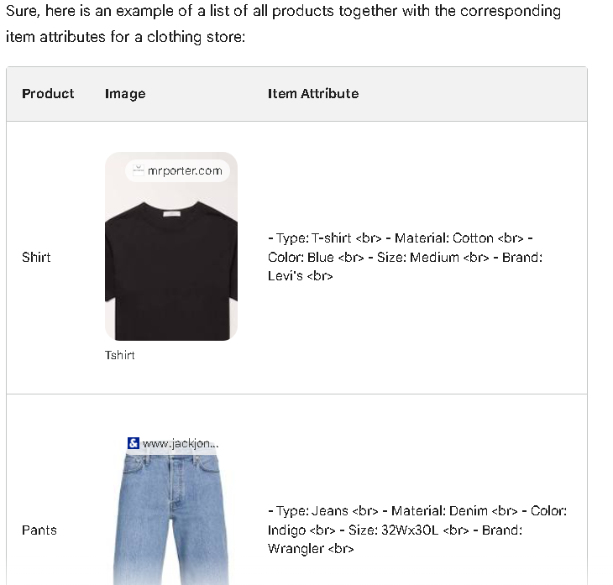

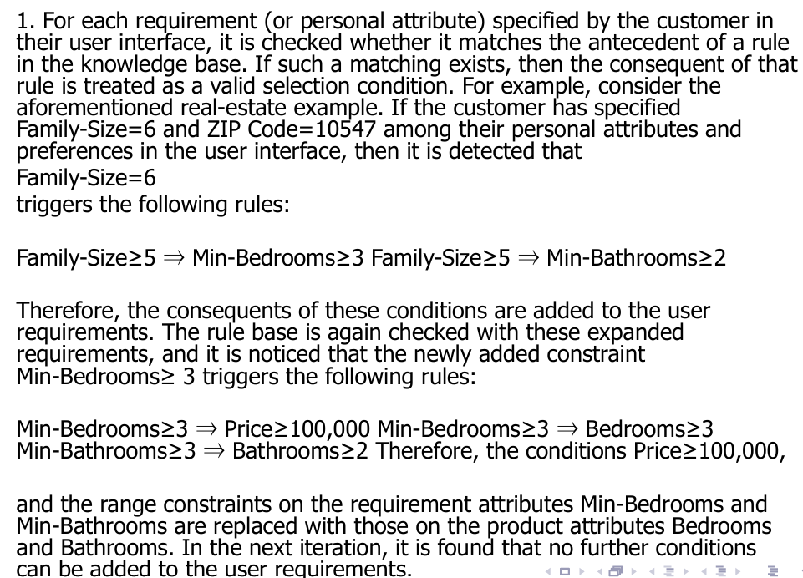

You've explained the first step of creating a filtering query for constraint-based recommender systems (CBRS) very well! Let's break down what you've described:

**Matching User Requirements to Rules:**

* The system begins by examining each user-specified requirement (e.g., family size of 6) and checking if it matches the "if" part (antecedent) of any rule in the knowledge base.
* If there's a match, the "then" part (consequent) of the rule becomes a valid filter for selecting products.

**Example: Expanding User Requirements:**

* You've provided a great example from the real estate domain. If a user specifies a family size of 6, the system finds rules stating:
  + **Family size of 5 or more:** This triggers minimum requirements of 3 bedrooms and 2 bathrooms.
* These additional requirements are then added to the user's initial preferences.

**Chained Rule Application:**

* The process doesn't stop there. The system now re-checks the knowledge base with the expanded requirements (including minimum bedrooms and bathrooms).
* This might trigger further rules based on the new constraints. In your example, the minimum bedroom requirement leads to additional rules about minimum price and actual number of bedrooms (not just minimum).

**Iterative Refinement:**

* This process of checking rules, adding consequents as filters, and re-checking continues until no further rules are triggered by the current set of requirements.

**Overall, you've accurately described the first step of building a filtering query in CBRS. The system iteratively leverages user requirements and domain knowledge to progressively refine the search criteria and identify the most relevant products.**

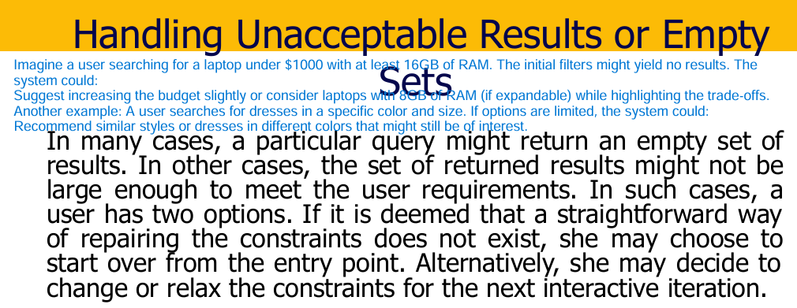

1. **Start Over:** The user can choose to return to the beginning and redefine their constraints. This might be suitable if they realize their initial requirements were too specific or if they want to explore different options entirely.
2. **Relax Constraints:** The user can opt to adjust their initial constraints, making them less strict. This can involve:
   * **Prioritizing:** Identifying the most important constraints and keeping those fixed, while loosening less crucial ones.
   * **Modifying Ranges:** Expanding the acceptable range for numerical constraints (e.g., increasing the budget for a product).
   * **Removing Constraints:** Completely eliminating a constraint if the user is open to considering options that don't fulfill that specific requirement.

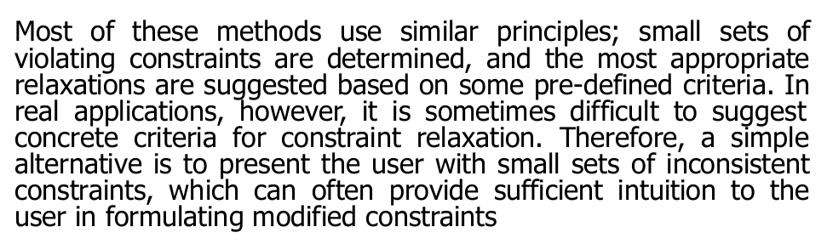

While constraint-based recommender systems (CBRS) can suggest constraint relaxation strategies, there are limitations and alternative approaches. Here's a breakdown of the key points:

**Challenges of Automatic Relaxation:**

* **Predefined Criteria:** Defining rigid criteria for relaxing constraints can be difficult. What constitutes a "more important" constraint can vary depending on the user and the specific situation.
* **Nuance and Context:** Automatic relaxation might struggle to capture the user's intent and the context of their needs. A seemingly minor relaxation might have unintended consequences.

**Alternative Approach: Highlighting Inconsistent Constraints:**

* **User Intuition:** Instead of suggesting specific relaxations, the system can present the user with the set of constraints causing conflicts (inconsistencies).
* **Empowering Users:** This approach trusts the user's judgment. By seeing which constraints are incompatible, they can often develop their own, more nuanced approach to modifying them.

**Benefits of Highlighting Inconsistencies:**

* **Transparency:** Users understand why certain combinations of constraints are not yielding results.
* **User Control:** They retain full control over the modification process, tailoring it to their specific needs and priorities.
* **Exploration:** This approach can encourage users to explore alternative combinations of constraints they might not have considered initially.

**Example:**

Imagine a user searching for a vacation rental. They specify a strict budget, a minimum number of bedrooms, and a beachfront location. The system might find these constraints are inconsistent (e.g., beachfront rentals may be more expensive). Instead of suggesting a budget increase, the system could highlight the conflicting constraints:

* Budget: Under $1000/night
* Minimum Bedrooms: 3
* Location: Beachfront

By seeing this, the user might decide to:

* Relax the location requirement and consider rentals near the beach but not directly on it.
* Increase their budget slightly to accommodate beachfront options.
* Reduce the number of bedrooms if flexibility is possible.

**Overall, you've highlighted a valuable alternative approach for CBRS. In cases where automatic relaxation is challenging, presenting users with inconsistent constraints empowers them to make informed decisions and guide the recommendation process based on their own understanding of their needs.**

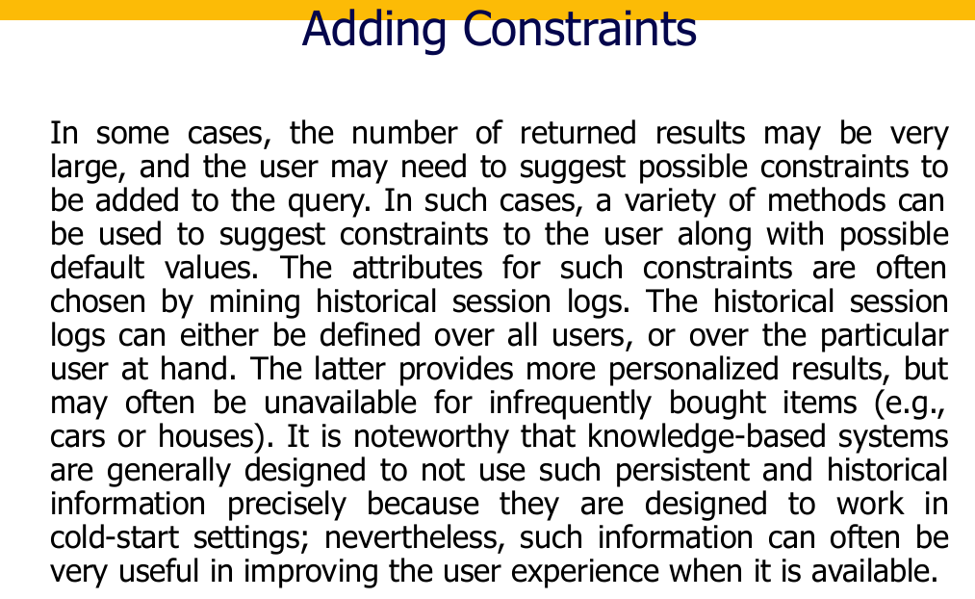

The passage describes a technique for improving user experience in search queries that might return a large number of results. Here's a breakdown of the key points:

**Problem:** When a user's search query is broad, it can return a lot of irrelevant or overwhelming information.

**Solution:** Suggesting constraints to narrow down the search results.

**Methods:**

* **Mining historical session logs:** Analyze past searches (either for all users or the specific user) to identify common ways users refine their queries for similar items. This helps suggest relevant constraints and potentially default values.
* **Personalized vs. General:** Analyzing a user's specific search history offers more personalized suggestions. However, for infrequent purchases (like cars or houses), such data might be unavailable.

**Knowledge-based systems vs. User Experience:** Traditionally, knowledge-based systems avoid relying on user history as they aim to function without prior data (cold-start). However, in this case, user history can significantly improve the search experience.

**Overall:** This approach leverages user behavior data to offer a more efficient and user-friendly search experience, especially when dealing with potentially vast datasets.

Imagine you're searching online for a new pair of running shoes. That's a broad query, right? Here's how suggesting constraints can help:

* **Problem:** A simple "running shoes" search might return thousands of results for all types of shoes, brands, and prices.
* **Solution:** The search engine can analyze past searches (yours or everyone's) to understand how people typically narrow down running shoe options.
* **Example:** Based on past searches, the engine might suggest constraints like:
  + Brand (Nike, Adidas, etc.)
  + Price range (budget-friendly, premium)
  + Type of running (marathon, trail, etc.)
  + Features (cushioning, lightweight)
* **Personalized vs. General:** If you've previously searched for running shoes, the engine might pre-fill some constraints based on your history (personalized). But for infrequent purchases like a car, there might not be enough data for personalization.
* **Knowledge-based systems typically don't use past data (cold-start).** They might not know what "good" running shoes are without info. But in this case, using past searches helps the engine understand what users typically find useful in running shoes.

**Overall:** By learning from past searches, the system tailors the experience to your (or general user) needs, making it easier to find the perfect pair of running shoes without wading through a sea of irrelevant options.

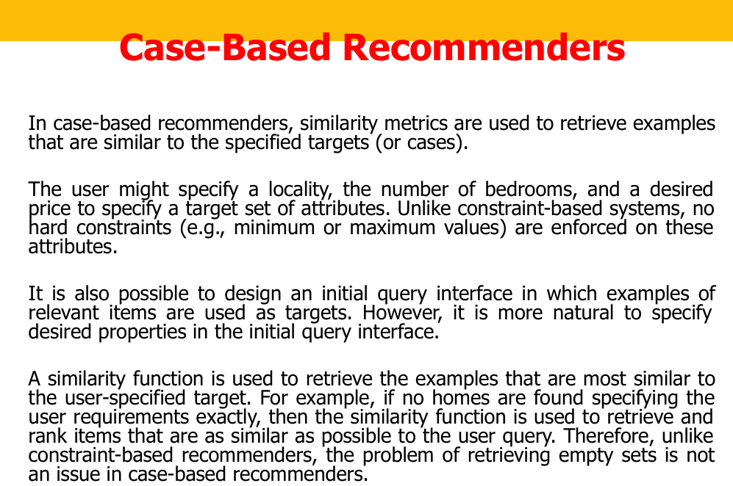

**Case-Based Recommenders Explained with Examples**

Case-based recommenders are a type of recommendation system that uses similarity to suggest items to users. Let's break it down with an example:

**Imagine you're looking for a new apartment.** Constraint-based systems might let you set hard filters like:

* Minimum bedrooms (2)
* Maximum rent ($2000)
* Specific neighborhood (Downtown)

**However, what if you're flexible?** Case-based recommenders come in:

* You provide a target: locality (Downtown-ish), number of bedrooms (around 2), and desired price range (around $2000).
* Unlike constraints, there are no hard cutoffs. You might be open to a 1-bedroom with a great balcony or a 3-bedroom slightly above budget.

**Here's how it works:**

1. **Similarity Metrics:** The system uses a special function to compare your target (desired apartment features) to existing apartments in its database.
2. **Finding Similar Examples:** This function considers factors like location proximity, bedroom count closeness, and price difference to find the most similar apartments.
3. **No Empty Results:** Even if there's no exact match, the system retrieves the closest options based on similarity. Unlike constraint-based systems that might return nothing if your filters are too strict.

**Additional Points:**

* You can also use examples as targets. Imagine browsing pictures of apartments you like. The system would then find similar ones based on those examples.
* This approach is flexible and caters to users who might not have perfectly defined needs.

**Benefits:**

* Handles user preferences beyond strict constraints.
* Offers a wider range of relevant options based on similarity.
* Avoids the problem of empty results in case-based systems.

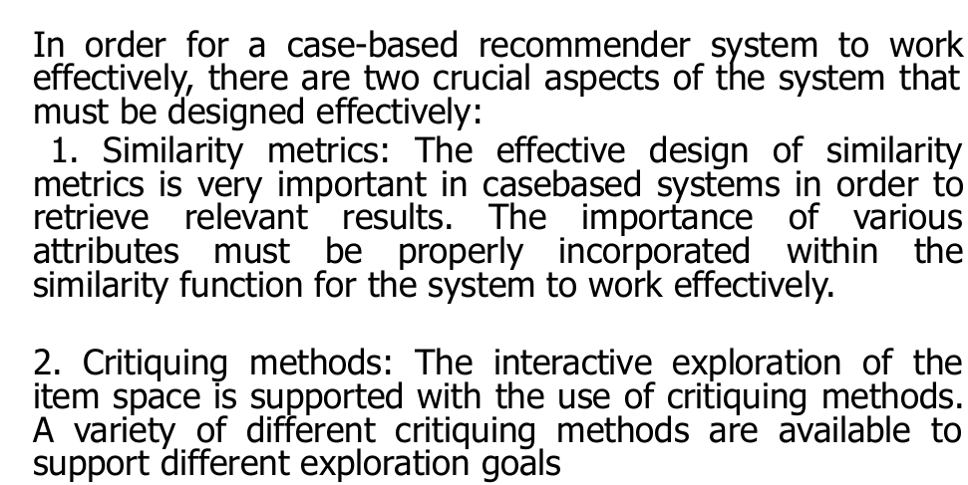

You're absolutely right. Here's a breakdown of those two crucial aspects for effective case-based recommender systems:

**1. Similarity Metrics: The Heart of Recommendation**

Imagine you're searching for a movie. A good similarity metric goes beyond just matching genres. It considers factors you might care about:

* **Balancing Importance:** A comedy with a great soundtrack might be more similar to a funny action movie than a slow drama, even if the genre is different. The metric should weigh the importance of various attributes (genre, actors, director) effectively.
* **Fine-tuning the Match:** Not all attributes hold the same weight. A one-star difference in rating might be less important than a completely different genre. The metric should consider the magnitude of differences in each attribute.

**Designing a good similarity metric is key** to retrieving relevant recommendations. It ensures the system prioritizes movies that align with your preferences based on how similar they are to your target (the movie you described as ideal).

**2. Critiquing Methods: Refining Your Search**

Let's say the initial recommendations aren't perfect. Critiquing methods allow you to interact and refine your search further:

* **Providing Feedback:** You might dislike action movies suggested for a comedy search. Critiquing allows you to tell the system "less action" or "more character-driven movies."
* **Different Exploration Goals:** Imagine searching for a new running shoe. You might want to prioritize comfort over brand, while another user might prioritize a specific brand. Critiquing methods should cater to these diverse goals.

Examples of critiquing methods include:

* **Rating Items:** You can rate suggested movies as thumbs up/down, indicating their relevance to your preferences.
* **Modifying Weights:** Going back to the movie example, you could increase the weight of "comedy" and decrease "action" to get more relevant suggestions.

**Effective critiquing methods** empower you to guide the recommendation system towards finding items that truly match your needs. It allows for an interactive search experience where you can refine and personalize your recommendations.

By focusing on these two crucial aspects, case-based recommender systems can deliver a more user-centric and effective recommendation experience.

**The importance of various attributes must be properly incorporated within the similarity function for the system to work effectively. means**

In a case-based recommender system, the **similarity function** is like a decision-maker. It determines how similar items in the system are to the target you (the user) specify. Since different featu...

In a case-based recommender system, the **similarity function** is like a decision-maker. It determines how similar items in the system are to the target you (the user) specify. Since different features (or attributes) of these items can hold varying importance to you, **properly incorporating** those **importances** within the similarity function is critical.

Here's a breakdown of why it matters:

* **Imagine searching for a new phone.** Some users might prioritize a great camera, while others might care more about battery life.
* A good similarity function wouldn't treat these features equally. It would consider how important each feature is to you (based on your target or past interactions).
* If the function prioritizes camera specs even though you didn't mention it, the recommendations might not be relevant.

Here's how the importance of attributes can be incorporated:

* **Assigning Weights:** Each attribute (camera, battery, etc.) can be assigned a weight depending on its importance. A higher weight signifies a more crucial factor for you.
* **Considering Magnitude of Differences:** The similarity function shouldn't just check if features match exactly. It should also consider how different the values are. For example, a slightly lower battery life might be less significant than a significantly worse camera.

By incorporating the importance of various attributes, the similarity function can make informed decisions about how similar items are to your target. This ensures the system recommends items that truly align with your preferences based on what matters most to you.



The slide defines a formula for calculating the similarity between two partially specified attribute vectors. Let's break down the key elements:

**Partial Attribute Vectors:**

* Imagine a product is described by various features (attributes) like brand, price, color, etc.
* These attributes can be represented as a vector where each position holds the value of a specific feature.
* In some cases, you might only care about a subset of these features when searching for a product.
* So, the focus is on partially specified attribute vectors, considering only a relevant subset of features.

**Target and Query Vectors:**

* The slide refers to two vectors: T (target) and X (query).
* These likely represent the product information you're looking for (target) and an existing product in the system (query).
* They might have values for different features (attributes), but only for a subset of all possible features (since they are partially specified).

**Similarity Function (f(T,X))**

* This formula calculates the similarity between the target (T) and the query (X) vectors.
* It essentially determines how close a match the query is to what you're looking for (target).

**Σ (sigma notation):**

* This symbol represents a summation over a set of elements.
* In this case, it likely iterates over each feature (attribute) in the subset being considered.

**wi (weights):**

* These represent the weights assigned to each feature (attribute) in the summation.
* As mentioned before, different features might hold varying importance in determining similarity.
* The weights (wi) capture this importance. A higher weight for an attribute signifies it's more crucial for similarity.

**Sim(ti, xi):**

* This part calculates the similarity between the corresponding features (ti and xi) in the target and query vectors, respectively.
* The exact way to compute this similarity might depend on the specific feature type (numeric values, categorical values, etc.).

**Overall, the formula considers a weighted sum of similarities between corresponding features in the target and query vectors. This provides a measure of how similar the query product is to your target product based on the specified attributes and their importance.**

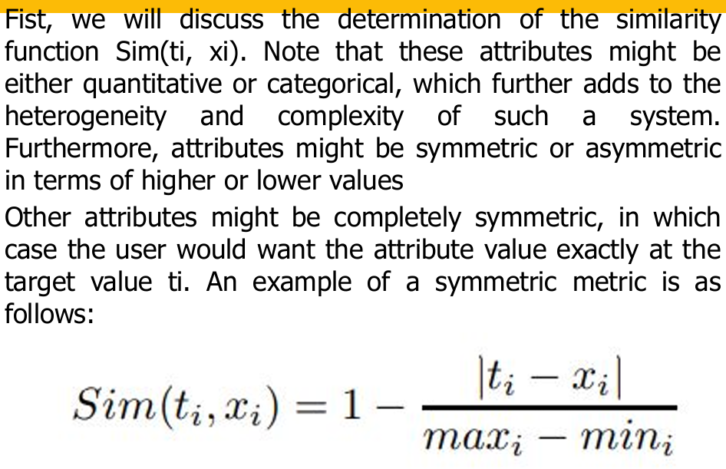

**Attributes (ti, xi):**

* As mentioned before, ti represents the value of a specific feature (attribute) in the target vector (what you're looking for).
* xi represents the value of the same feature (attribute) in the query vector (an existing product in the system).

**Categorical vs. Quantitative Attributes:**

* This formula can handle both categorical and quantitative attributes.
* For quantitative attributes (like screen size), the difference (ti - xi) is a meaningful numerical value.
* For categorical attributes (like color), the difference might not be directly comparable. In such cases, we can define a convention. For example, a difference of 1 between color categories (e.g., "red" and "blue") might indicate less similarity than a difference of 3 (e.g., "red" and "green").

**Symmetric vs. Asymmetric Attributes:**

* The formula treats higher and lower values symmetrically. This is because the difference (ti - xi) considers both directions.
* For example, imagine the target price (ti) is $100 (desired price) and the query price (xi) is $80. The difference is 20, which indicates the same level of dissimilarity as a target price of $100 and a query price of $120 (difference of -20).
* However, some attributes might be asymmetric. For instance, response time for a computer might be more critical for lower values (faster response is better). In such cases, a different similarity function might be needed that considers the asymmetry.

**Completely Symmetric Attributes:**

* The text mentions attributes where the user desires the exact target value (ti). This formula captures that scenario as well.
* If the query value (xi) perfectly matches the target value (ti), the difference (ti - xi) becomes zero. The maximum range (maxi - mini) will always be a positive value by definition. Therefore, the result of the formula (difference divided by range) becomes zero, indicating the highest possible similarity (a perfect match).

**Overall, the formula provides a general-purpose way to calculate similarity between features (attributes) in a case-based recommender system. It considers both quantitative and categorical attributes, treats symmetric differences equally, and assigns the highest similarity score to exact matches.**

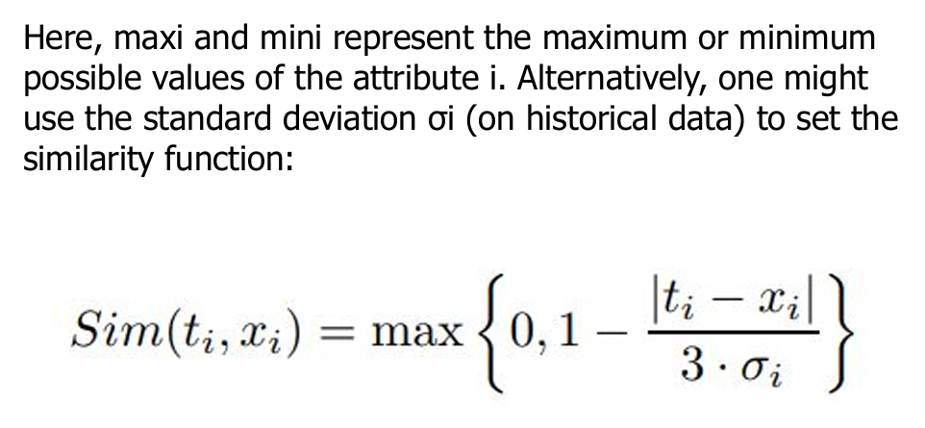

The image you sent shows a different formula for a similarity function compared to the previous one. This formula uses the standard deviation (σi) of the attribute i (historical data) to determine similarity.

Here's a breakdown of the formula and how it addresses the points mentioned in the text:

**Standard Deviation (σi):**

* This formula incorporates the standard deviation (σi) of the attribute i, likely calculated from historical data of past products in the system.
* Standard deviation is a measure of how spread out the values of an attribute are in a dataset.
* A higher standard deviation indicates more variation in the data, while a lower standard deviation suggests the values are clustered closer together.

**Sim(ti, xi):**

* This part calculates the similarity between the target value (ti) and the query value (xi) for attribute i, similar to the previous formula.
* However, instead of the maximum range (maxi - mini), it uses the standard deviation (σi).

**Addressing Heterogeneity:**

* This formula can be a more robust way to handle the heterogeneity (variety) of attribute values, especially for quantitative attributes.
* By considering the standard deviation, the function can account for how much a particular difference (ti - xi) deviates from the typical spread of values for that attribute.
* For example, a price difference of $10 might be a significant deviation for a low-cost product category with a low standard deviation, but it might be a smaller deviation for a high-priced product category with a high standard deviation.

**Alternative to Maximum Range:**

* The text mentions this formula as an alternative to using the maximum range (maxi - mini).
* The advantage of standard deviation is that it considers the specific distribution of values for each attribute, leading to potentially more nuanced similarity scores.

**In essence, this formula leverages the standard deviation of historical data to compute similarity. This can be a more flexible approach compared to a fixed maximum range, especially when dealing with attributes that exhibit variations in their values.**

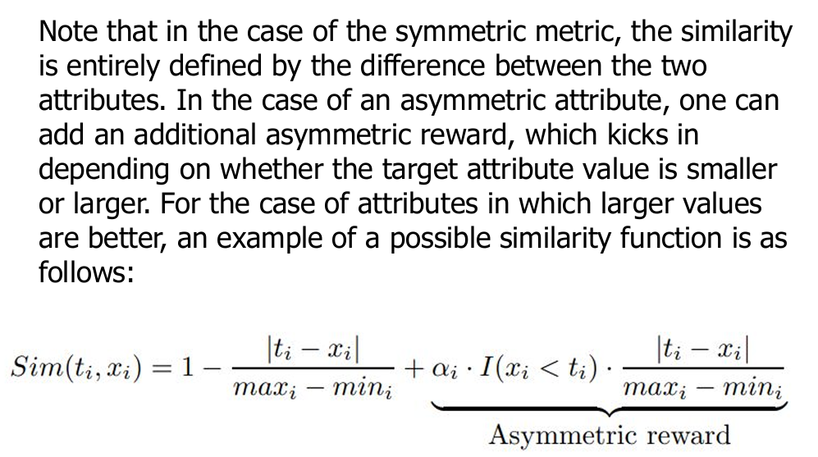

The concept you're describing is about incorporating asymmetry into similarity functions for case-based recommender systems. Let's break it down along with the image you sent:

**Symmetric vs. Asymmetric Attributes:**

* As discussed earlier, symmetric attributes are those where higher or lower values hold equal importance. The difference between the target and query value (ti - xi) captures similarity well.
* Asymmetric attributes, however, have a preference for either higher or lower values. For instance, response time in computers (lower is better) or house price (higher might be better depending on the context).

**Addressing Asymmetry with Asymmetric Rewards:**

* The text and the image you sent propose adding an "asymmetric reward" to the similarity function specifically for asymmetric attributes.
* This reward term essentially boosts the similarity score when the query value (xi) aligns with the preference for the attribute.

**The Image's Formula:**

The image shows a possible function for asymmetric attributes where larger values are better:

* **Sim(ti, xi):** This calculates the base similarity between the target value (ti) and the query value (xi), likely using a difference formula similar to previous examples.
* **I(xi < ti):** This is an indicator function. It equals 1 if the query value (xi) is less than the target value (ti), and 0 otherwise.
* **ai:** This is a weight factor specific to the attribute i. It determines the strength of the asymmetric reward. A higher weight signifies a stronger preference for higher values.

**How it Works:**

* When the query value (xi) is greater than or equal to the target value (ti) (preferred scenario for this case), the indicator function (I(xi < ti)) becomes 0. The asymmetric reward term (ai * I(xi < ti)) cancels out, and the similarity score relies only on the base similarity (Sim(ti, xi)).
* However, if the query value (xi) is less than the target value (ti) (undesirable scenario), the indicator function becomes 1. This activates the asymmetric reward term (ai * I(xi < ti)), adding a penalty to the similarity score. The magnitude of the penalty depends on the weight factor (ai).

**Overall, this approach allows the similarity function to consider both the base similarity between values and the preference for higher values in asymmetric attributes.**

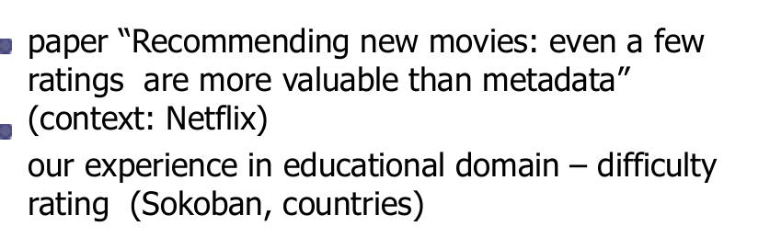

The paper "Recommending new movies: even a few ratings are more valuable than metadata" likely highlights the strengths of collaborative filtering over content-based filtering in the context of Netflix movie recommendations. Here's a breakdown of the key points and how it relates to your experience:

**Content-Based Filtering (CBF):**

* Relies on **item content analysis** (descriptions, actors, genre) to recommend similar items.
* **Strengths:** Works well for domains with rich, easily analyzable content (e.g., product descriptions).
* **Weaknesses:** Limited for multimedia (movies!), struggles with complex content, and requires good domain knowledge for accurate analysis.

**Collaborative Filtering (CF):**

* Focuses on **user-to-user relationships** based on past ratings or interactions. Users with similar tastes are likely to enjoy similar items.
* **Strengths:** Effective even with limited item content, works well for movies where user ratings provide valuable insights.
* **Weaknesses:** Relies on sufficient user data to establish relationships, can lead to "echo chambers" if not implemented carefully.

**The Netflix Paper's Argument:**

The paper likely argues that even a few user ratings are more valuable than just movie metadata for recommendations. This makes sense because:

* **Movie descriptions** might not capture the nuances of a film (acting style, humor, etc.).
* **User ratings** provide a more direct indication of user preferences. Even a few ratings can reveal user tastes and connect them to similar users who can guide recommendations.

**Educational Domain Example:**

You mentioned difficulty rating for educational content (Sokoban puzzles, countries). This is an interesting case:

* **CBF could potentially work** for Sokoban puzzles if difficulty is based on factors like number of moves or complexity. It could recommend similar difficulty puzzles.
* **CBF might struggle** with countries. Geographical location or basic information might not predict user interest. Cultural significance or historical events might be more relevant, which are harder to analyze automatically.

**Collaborative Filtering could be more effective** for both these scenarios:

* **Sokoban:** If users rate puzzle difficulty, the system can connect users who enjoy similar challenges, recommending puzzles based on user preferences.
* **Countries:** User ratings for different countries can reveal user interests (history buffs, travel enthusiasts). The system can then recommend countries based on these learned user preferences.

**Overall, the choice between content-based and collaborative filtering depends on the domain and the data available. In cases like movie recommendations or educational content where user ratings are available, collaborative filtering can leverage this valuable data to provide more personalized and effective recommendations.**

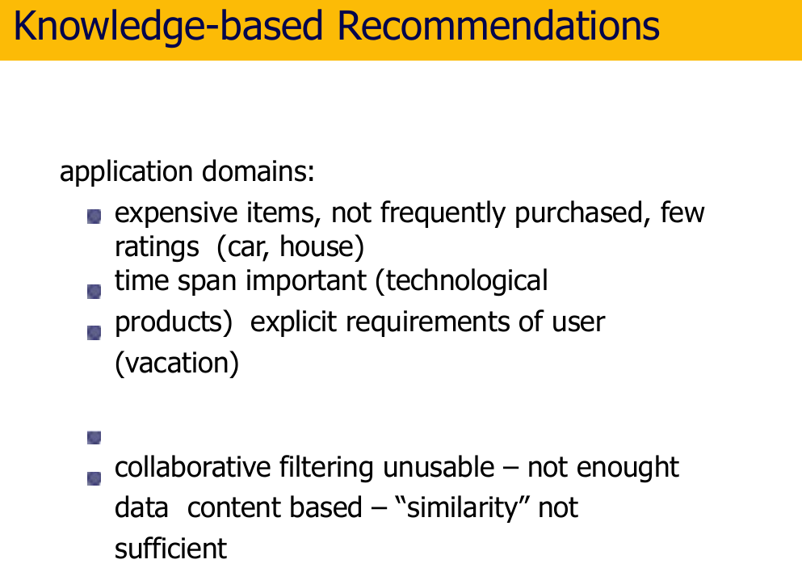

Knowledge-based recommendations shine in situations where collaborative filtering and content-based approaches fall short. Here's a breakdown of why knowledge-based recommendations are well-suited for specific application domains:

**Domains for Knowledge-Based Recommendations:**

* **Expensive, Infrequent Purchases (Cars, Houses):**
  + Collaborative filtering struggles due to limited data (not many buy houses frequently).
  + Content-based analysis might not capture the full picture (a picture doesn't tell the whole story about a house).
  + Knowledge-based systems can incorporate rich information (features, location, market trends) to recommend suitable options.
* **Time-Sensitive Products (Tech Products):**
  + User ratings might become outdated quickly for fast-evolving technology.
  + Knowledge-based systems can consider factors like release dates, specs, and user reviews to suggest the latest and most relevant products.
* **Explicit User Requirements (Vacations):
  + Collaborative filtering might not capture the nuances of a desired vacation (relaxing vs. adventurous).
  + Content-based analysis of travel destinations might be limited.
  + Knowledge-based systems can handle user-specified criteria (budget, desired activities, travel style) to recommend personalized vacation options.

**Advantages of Knowledge-Based Recommendations:**

* **Reduced Reliance on Data:** They don't heavily rely on user ratings (often scarce for these domains) for effective recommendations.
* **Constraint-Based Search:** Users can specify desired features, allowing for a more focused search process.
* **Case-Based Reasoning:** They can leverage past successful recommendations based on similar user requirements.
* **Conversational Recommendation:** Systems can interact with users, refining recommendations based on feedback and clarifying user needs.

**Knowledge-Based Techniques:**

* **Constraint Satisfaction Problems (CSPs):** Formulating user requirements as constraints that the system needs to satisfy when recommending items.
* **Case-Based Reasoning (CBR):** Matching user needs to past successful recommendations with similar requirements.

**Overall, knowledge-based recommender systems offer a powerful approach for domains where traditional techniques struggle. By leveraging domain knowledge and user-specified requirements, they can provide a more targeted and effective recommendation experience.**

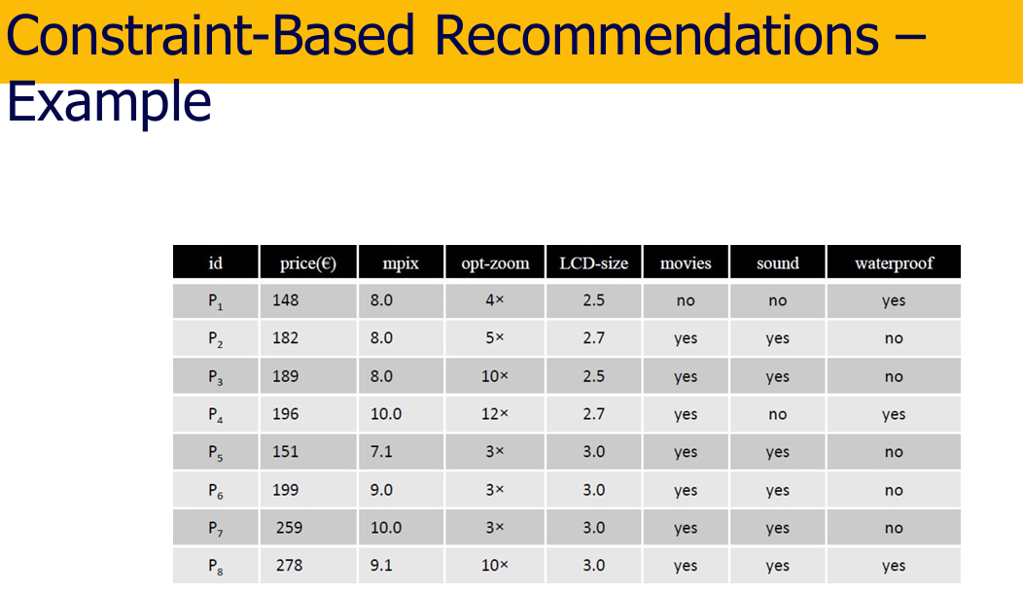

constraint-based recommender system, which is a type of knowledge-based recommender system. It is well-suited for situations where collaborative filtering and content-based approaches fall short, such as recommending expensive or infrequent purchases (cars, houses) or time-sensitive products (tech products).

Here's a breakdown of the key elements in the image:

* **Table:** The table represents a collection of items (possibly cars) with various attributes (features) listed in the columns. Each row likely represents a different car model.
* **Attributes:** These are the features or characteristics of each item (car). Examples in the image include "id," "price," "mpix" (megapixels for camera), "opt-zoom" (optical zoom), "LCD-size," "movies," "sound," and "waterproof."
* **Constraints:** These are not shown explicitly in the table, but they are the key concept in constraint-based recommender systems. They represent the user's preferences or requirements for the item they are looking for. For instance, a user constraint might be "price less than $200" or "waterproof."

**How it Works:**

1. **User Input:** The user specifies their constraints (desired features or requirements) for the item they're looking for.
2. **Constraint Satisfaction:** The system then analyzes the table of items, searching for entries where all the user's constraints are satisfied.
3. **Recommendations:** The system recommends items (cars) from the table that meet all the user's specified constraints.

**Benefits:**

* **Flexibility:** Users can specify a wide range of constraints to narrow down their search.
* **Transparency:** The recommendation process is clear and easy to understand for the user. They can see why specific items are recommended based on their constraints.
* **Accuracy:** Since recommendations are based on meeting all constraints, the system can provide highly relevant results.

**Limitations:**

* **Complexity:** Defining constraints can become complex for products with many attributes.
* **Scalability:** As the number of items and attributes grows, the search process can become computationally expensive.

**Overall, constraint-based recommender systems are a valuable approach for recommending complex items where users have specific requirements. They offer flexibility, transparency, and accuracy in the recommendation process.**

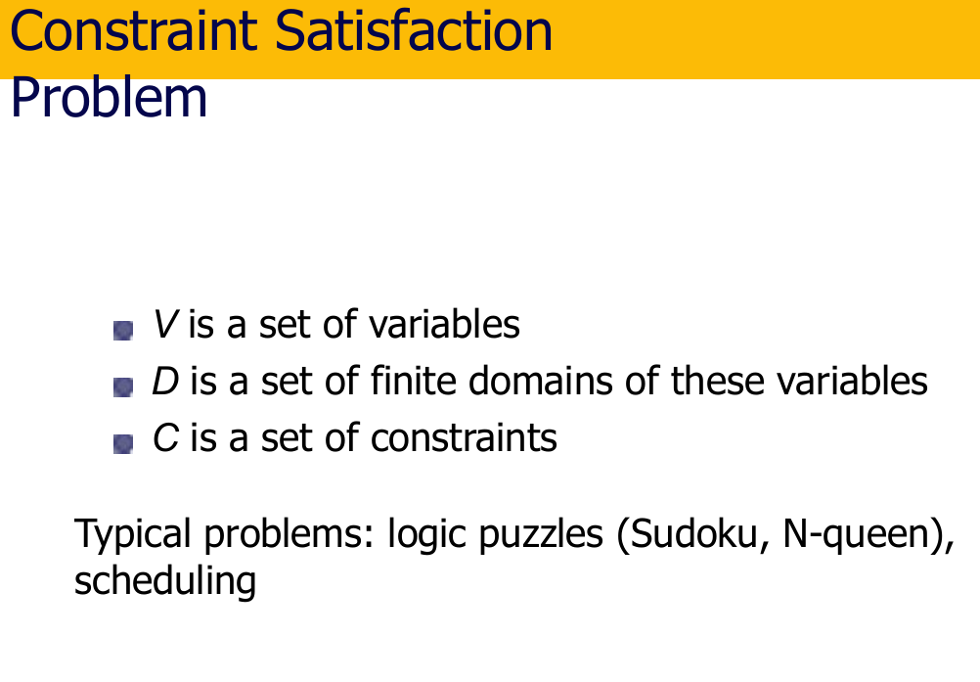

The concept you described is called a Constraint Satisfaction Problem (CSP). It's a powerful framework for solving problems where you have a set of variables and restrictions on their possible values. Here's a breakdown of the key elements and some typical applications:

**Components of a CSP:**

* **Variables (V):** These represent the things you're trying to decide or assign values to. In the image you sent, the variables could be the cells in a Sudoku puzzle, each needing a number assigned.
* **Domains (D):** These define the set of possible values each variable can take. In Sudoku, each cell's domain is the numbers 1 to 9.
* **Constraints (C):** These are the rules that limit how variables can be assigned values simultaneously. They restrict combinations of variable assignments that violate the problem's logic. For example, in Sudoku, a constraint might be that no row or column can have the same number repeated.

**Solving a CSP:**

The goal is to find an assignment of values to all variables such that all the constraints are satisfied. Various algorithms exist to solve CSPs, depending on the complexity of the problem.

**Typical CSP Applications:**

* **Logic Puzzles (Sudoku, N-Queens):** The variables are the cells in the puzzle, the domains are the possible values (numbers), and the constraints ensure no row, column, or specific pattern (like diagonals in N-Queens) has repeated values.
* **Scheduling:** Variables could represent tasks, domains could be available time slots, and constraints ensure tasks don't overlap due to resource limitations or dependencies between tasks.
* **Resource Allocation:** Variables could be resources, domains could be available quantities, and constraints ensure sufficient resources are allocated to fulfill specific needs without exceeding capacity.
* **Course Scheduling (Student Registration):** Variables could be course slots, domains could be available times, and constraints ensure students don't have conflicting classes and professors don't teach multiple classes at the same time.

**Constraint-Based Recommenders and CSPs:**

The concept of constraint satisfaction is also used in constraint-based recommender systems. Here, the variables represent item attributes (e.g., price, features), the domains are the possible values for those attributes, and the constraints represent the user's preferences for the item they are looking for. The system searches for items where all the user's constraints (desired features) are satisfied.

**Overall, Constraint Satisfaction Problems (CSPs) provide a versatile framework for solving various problems where you have variables, limitations on their values, and need to find a combination that satisfies all the rules.**

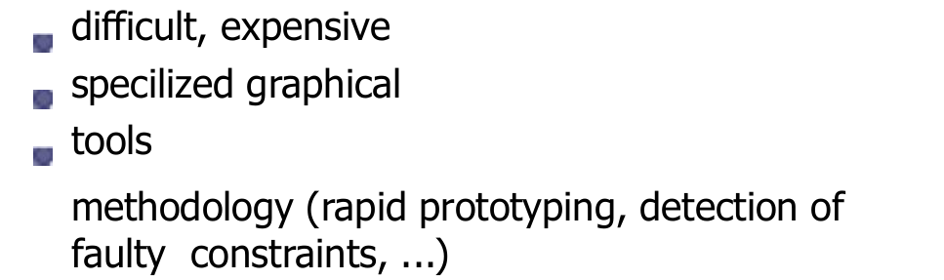

You're absolutely right. Developing knowledge bases can be a challenging and resource-intensive process. Here's a breakdown of the key difficulties and some methodologies to address them:

**Difficulties in Knowledge Base Development:**

* **Domain Expertise:** Creating an accurate and comprehensive knowledge base requires deep understanding of the domain and the relationships between concepts.
* **Data Acquisition:** Gathering the necessary data (customer information, product details, domain knowledge) can be complex and time-consuming.
* **Data Quality:** Data inconsistencies, errors, and missing information can significantly impact the effectiveness of the knowledge base.
* **Knowledge Representation:** Choosing the right way to structure and represent knowledge in the system is crucial for efficient reasoning and retrieval.
* **Maintenance:** Knowledge bases need to be updated regularly to reflect changes in the domain, customer preferences, and product offerings.

**Methodologies for Efficient Development:**

* **Rapid Prototyping:**
  + Build a basic knowledge base with minimal functionality initially.
  + Get feedback from users and domain experts to refine and iterate on the knowledge base.
  + This helps identify and address issues early in the development process.
* **Incremental Development:**
  + Break down the knowledge base development into smaller, manageable tasks.
  + Focus on building core functionalities first, then gradually add complexity.
* **Knowledge Acquisition Techniques:**
  + Utilize structured interviews with domain experts.
  + Leverage existing data sources like customer records and product manuals.
  + Employ machine learning techniques to extract knowledge from text (e.g., product descriptions).
* **Data Validation and Cleaning:**
  + Implement data quality checks to identify and correct errors or inconsistencies.
  + Establish data cleansing procedures to ensure high-quality data in the knowledge base.
* **Specialized Graphical Tools:**
  + Utilize knowledge base development tools that offer visual interfaces for easier knowledge representation and editing.
  + These tools can help domain experts who might not have programming expertise contribute to the knowledge base creation.
* **Constraint Detection and Debugging:**
  + Integrate mechanisms to identify faulty constraints or knowledge inconsistencies.
  + Provide functionalities for diagnosing and resolving issues within the knowledge base.

**Benefits of Effective Methodologies:**

* **Reduced Development Time and Cost:** By employing efficient methodologies, development becomes faster and less resource-intensive.
* **Improved Knowledge Base Quality:** Focus on data quality, knowledge representation, and validation leads to a more accurate and reliable knowledge base.
* **Easier Maintenance and Update:** Modular development and knowledge acquisition techniques make it easier to keep the knowledge base up-to-date.

**Overall, developing knowledge bases is a complex task, but by utilizing appropriate methodologies and tools, the process can be streamlined, leading to a high-quality and valuable knowledge base for your recommender system or other applications.**

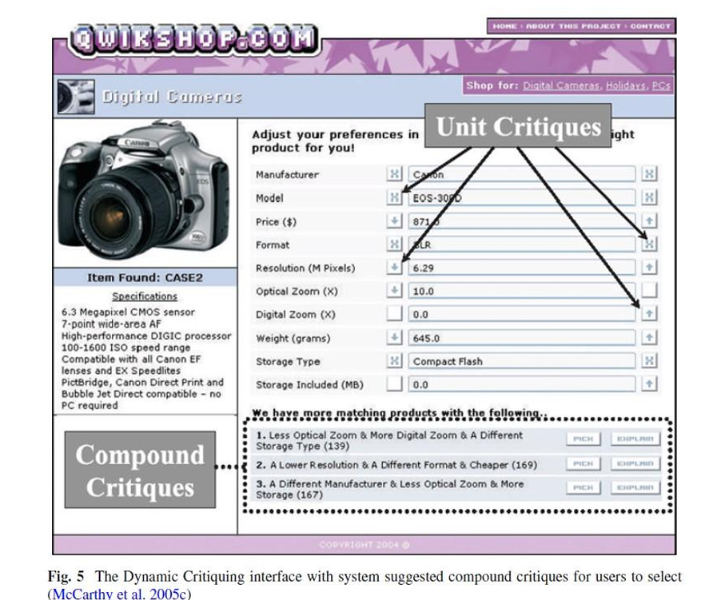

The image you sent depicts a critiquing interface from a recommender system specializing in digital cameras [1]. Critiquing recommender systems allow users to iteratively refine recommendations provided by the system based on their preferences.

In the image, the critiquing interface is being used to recommend a digital camera to the user. Here’s a breakdown of the interface:

* **Shop for:** This section shows the category of products the recommender system focuses on, which is digital cameras.
* **Adjust your preferences in:** This section allows users to refine the recommender system’s suggestions based on their preferences. In the image, “Unit” is selected from a dropdown menu, likely indicating that the user wants to provide feedback on the features of a particular camera.
* **Critique:** This section displays the camera currently being recommended by the system. The camera’s details include:
  + **Manufacturer:** Canon
  + **Model:** HEOS-3090
  + **Price:** $8710
  + **Format:** XLR
  + **Resolution:** 6.29 Megapixels
  + **Other specifications:** Optical Zoom (10x), Digital Zoom (0x), Weight (645.0 grams), Storage Type (X Compact Flash), etc.
* **We have more matching products with the following:** Here, the system suggests additional critiques (compound critiques) that the user can select to refine their search. These critiques consider multiple features of the camera. In the image, three compound critiques are displayed:
  + **Less Optical Zoom & More Digital Zoom & A Different Storage Type** (139 matching products)
  + **A Lower Resolution & A Different Format & Cheaper** (169 matching products)
  + **A Different Manufacturer & Less Optical Zoom & More Storage** (167 matching products)
* **Copyright 2004:** This indicates the year the webpage was designed.

By clicking on one of the compound critiques, the user can instruct the system to find cameras that better suit their needs. For instance, if the user selects the critique “Less Optical Zoom & More Digital Zoom & A Different Storage Type”, the system would then recommend cameras with less optical zoom, more digital zoom, and a storage type different from X Compact Flash.

Critiquing recommender systems can be useful for shoppers who are unsure exactly what they are looking for but have a general idea of the features they prefer. The iterative process allows users to refine their search until they find a camera that meets their needs.

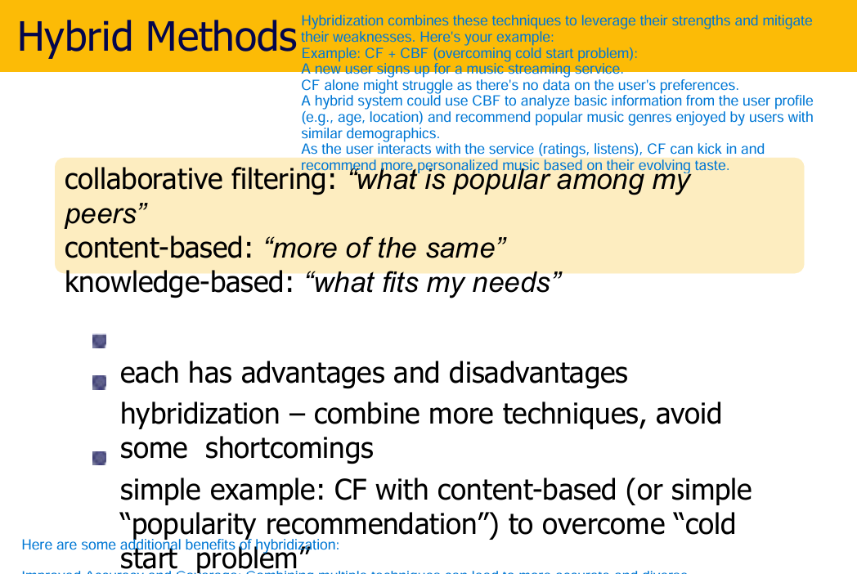

Here's a breakdown of the strengths and weaknesses of the three main recommender system approaches, along with how hybridization helps:

**Recommender System Approaches:**

* **Collaborative Filtering (CF):**
  + **Advantages:** Good at capturing user preferences based on past interactions (purchases, ratings, etc.). Can recommend niche items based on user similarities.
  + **Disadvantages:** Susceptible to the "cold start problem" for new users or items. Can lead to echo chambers if not implemented carefully.
  + **Example:** Recommending movies to you based on what similar users with similar taste have watched.
* **Content-Based Filtering (CBF):**
  + **Advantages:** Good at recommending items similar to what a user has liked in the past ("more of the same"). Works well for new items with sufficient descriptive features.
  + **Disadvantages:** Relies heavily on the quality and detail of item descriptions. May struggle with users who have diverse taste.
  + **Example:** Recommending books based on genre, author, or keywords if a user liked a particular book.
* **Knowledge-Based Recommender Systems (KBRS):**
  + **Advantages:** Can provide highly personalized recommendations based on user needs and item features. Can handle complex relationships between items.
  + **Disadvantages:** Requires significant effort to build and maintain a knowledge base. Relies on the accuracy and completeness of the knowledge base.
  + **Example:** Recommending a new laptop based on user-specified criteria like processing power, RAM size, and budget.

**Hybridization:**

Hybridization combines these techniques to leverage their strengths and mitigate their weaknesses. Here's your example:

* **Example: CF + CBF (overcoming cold start problem):**
  + A new user signs up for a music streaming service.
  + CF alone might struggle as there's no data on the user's preferences.
  + A hybrid system could use CBF to analyze basic information from the user profile (e.g., age, location) and recommend popular music genres enjoyed by users with similar demographics.
  + As the user interacts with the service (ratings, listens), CF can kick in and recommend more personalized music based on their evolving taste.

Here are some additional benefits of hybridization:

* **Improved Accuracy and Coverage:** Combining multiple techniques can lead to more accurate and diverse recommendations.
* **Flexibility:** Hybridization allows for customization based on the specific application and data available.

Overall, hybridization is a powerful approach to building robust and effective recommender systems.

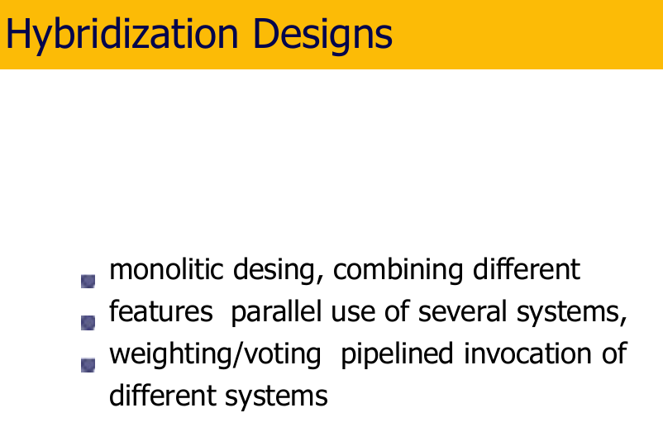

There are several ways to combine recommendation techniques in a hybrid recommender system. Here's a breakdown of the four main hybridization designs:

1. **Monolithic Design:**
   * In this design, different recommendation techniques are combined within a single model.
   * The model considers features generated by each technique (e.g., user-item interaction data for CF, item features for CBF, and user-item relationships from KBRS) and learns a unified scoring function to predict user preferences.
   * **Advantages:** Relatively simple to implement, allows for strong feature interaction and joint optimization.
   * **Disadvantages:** Can be complex to design and train, may require large datasets for effective learning.
2. **Parallel Design (Weighted/Voting):**
   * This design involves running multiple recommendation systems independently.
   * Each system generates its own recommendations for the user.
   * The final recommendation list is formed by combining the individual recommendation lists using a weighting or voting scheme.
     + **Weighting:** Assigns a weight to each recommendation list based on its perceived reliability or relevance.
     + **Voting:** Each recommendation gets a "vote," and the top items with the most votes are included in the final list.
   * **Advantages:** Modular and easy to implement, allows for easy integration of new recommendation techniques.
   * **Disadvantages:** May not capture the relationships between recommendations from different techniques.
3. **Pipelined Design:**
   * This design structures the recommendation process as a sequence of stages.
   * The output from one stage becomes the input for the next stage.
   * For instance, a CF system might recommend a set of initial items, and then a CBF system could be used to refine these recommendations based on item content.
   * **Advantages:** Allows for tailored use of different techniques at different stages of the recommendation process.
   * **Disadvantages:** Can be more complex to design and requires careful consideration of the order of stages.
4. **Hybrid Recommendation with User Interaction:**
   * This design incorporates user feedback into the recommendation process.
   * The system might initially present recommendations from a hybrid approach, and then allow users to provide feedback (e.g., thumbs up/down, indicating preferred features) to further refine the recommendations.
   * **Advantages:** Leverages user feedback for improved personalization and can help address the cold start problem.
   * **Disadvantages:** Requires an interface for user feedback and may add complexity to the user experience.

The best choice of hybridization design depends on the specific application, data availability, and desired level of complexity.

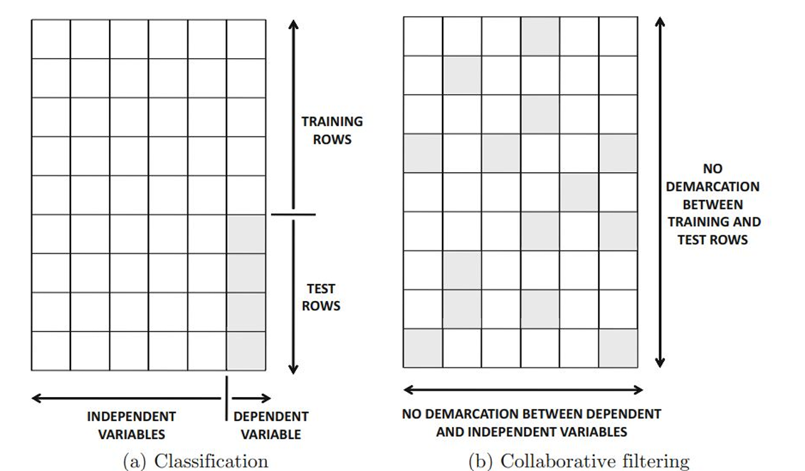

The image you sent depicts a graph showcasing the connection between training and test rows in recommender systems. It illustrates two scenarios: classification and collaborative filtering.

**Classification**

* **Training Rows:** These rows represent the data used to train the recommender system. They encompass user interactions (ratings, purchases, etc.) and item features (descriptions, genres, etc.). The model learns from these interactions to identify patterns and relationships between users and items.
* **Test Rows:** Once trained, the model is evaluated using test rows. These rows contain user or item data that the model hasn't seen before. The model predicts recommendations for these users or items based on what it learned from the training data.
* **No Demarcation:** In classification, there's a clear separation between training and test rows. The training data is used to build the model, and the test data is used to assess its performance on unseen data.

**Collaborative Filtering**

* **Training Rows:** Similar to classification, training rows provide user-item interaction data for the model to learn from.
* **Test Rows:** Test rows also include user or item data, but here, there's a crucial difference. Collaborative filtering techniques often use a single dataset for both training and testing. This means a portion of the data (user ratings or interactions) is withheld from the model during training. This withheld data becomes the test set.
* **No Demarcation Between Training and Test Rows:** Because a single dataset is used for both training and testing, there's no distinct demarcation between training and test rows in collaborative filtering. The model is essentially trained on a subset of the data and tested on the remaining subset.

**Key takeaway:** The distinction between training and test data is crucial for evaluating the effectiveness of recommender systems. Classification systems maintain a clear separation, while collaborative filtering might blur the lines a bit by using the same dataset for both training and testing purposes, with a portion held out for evaluation.

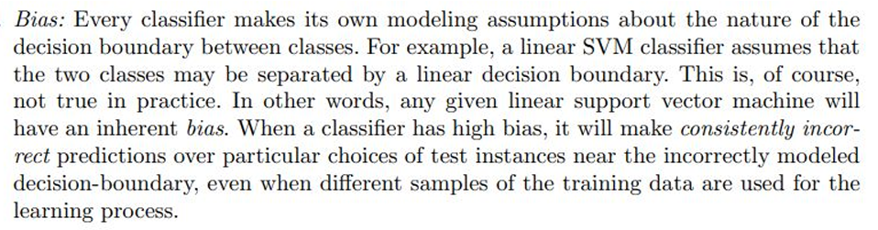

the concept of bias in machine learning, specifically in the context of decision boundaries.

Here's a breakdown of the relevant concepts:

* **Decision boundary:** A decision boundary is a line or hyperplane that separates the feature space into different classes. It's a way for machine learning models to classify new data points based on the learned patterns from the training data.
* **Bias:** Bias refers to the inherent assumptions of a machine learning model. These assumptions can impact the model's ability to generalize to unseen data. In the case of decision boundaries, a linear model might make the assumption that a straight line can perfectly separate the data into two classes, when in reality the data may not be linearly separable. This can lead to the model making consistently wrong predictions for certain data points, especially those that fall close to the incorrectly modeled decision boundary.

So, to summarize the text in the image, every machine learning classifier makes its own assumptions about the decision boundary. These assumptions can introduce bias into the model, which can lead to inaccurate predictions.

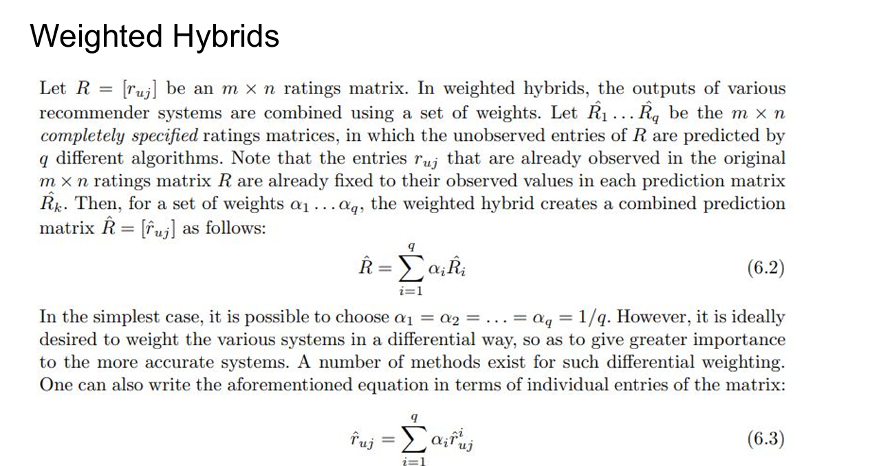

The image you sent explains weighted hybrids, which is a technique used in recommender systems to combine the predictions of multiple recommender systems.

The text describes a scenario where you have a ratings matrix R, which shows how users have rated different items. This matrix can be huge, with many missing entries where users haven’t rated certain items.

Recommender systems try to predict the missing entries in this matrix. The text describes how weighted hybrids can do this by combining the predictions of several recommender systems.

Here’s how it works:

* You have a set of recommender systems, lets say q of them, that are each capable of predicting the missing entries in the ratings matrix R.
* Each recommender system outputs a predicted ratings matrix, denoted by R1​^​...Rq​^​.
* These predicted ratings matrices have the same dimensions (m x n) as the original ratings matrix R.
* In a weighted hybrid system, each recommender system’s predictions are weighted according to a weight α.
* The weights are a set of values, α₁,...,αq, where each αᵢ corresponds to a recommender system, Ri​^​.
* Ideally, these weights should be assigned such that more accurate recommender systems are given higher weights.
* The final prediction, denoted by ̂R, is calculated by summing the weighted predictions from each recommender system.

The text mentions two ways to write this mathematically:

* Equation (6.2) shows the weight sum for the entire matrix.
* Equation (6.3) shows the weight sum for individual entries (ratings) in the matrix.

The simplest way to assign weights is to give all the recommender systems equal weights (i.e. α₁ = α₂... = αq = 1/q). However, the text says it’s better to assign weights based on how accurate each recommender system is.

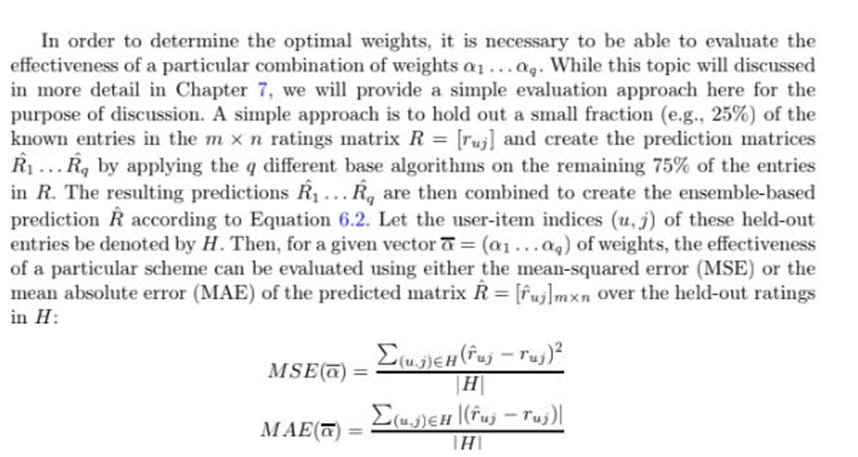

injecting randomness into a neighborhood model for collaborative filtering:

**Standard Neighborhood Model:**

* This model identifies the k closest neighbors (users or items) based on similarity to predict a rating for a user-item pair.

**Randomness Injection Approach:**

1. **Expand the pool:** It expands the pool of potential neighbors by considering a larger set (α times the original k).
2. **Random selection:** It randomly selects k neighbors from this expanded pool (α * k).

**Why it works:**

* By randomly choosing neighbors, the model avoids relying on the exact same set of neighbors every time. This injects diversity, reducing the chance of overfitting to specific patterns in the data.